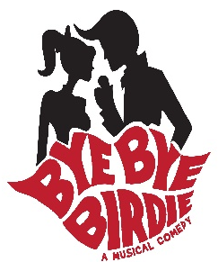

Bye Bye Birdie Hair:
Teens – arrive with high pony tail or high side tail, bob if shorter hair.
Boys/Men - hair should be neat- parted and gelled.
Anyone playing an adult character could have either a bun or bob, no pony tail.

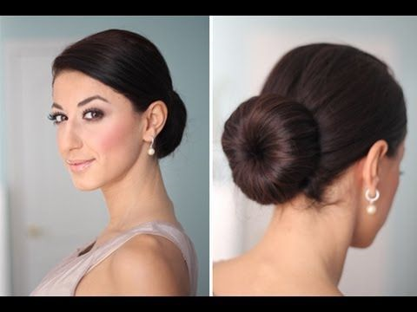

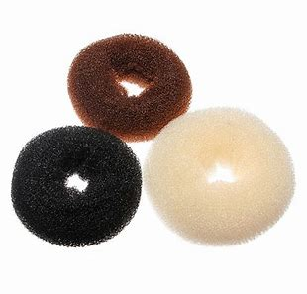
Link to the tutorial: https://www.bing.com/videos/search?q=low+bun+doughnut+Tutorial&&view=detail&mid=2330EE5E8B022EFB3D842330EE5E8B022EFB3D84&&FORM=VRDGAR

We have 2 makeup volunteers, Tanya Roseberry & Amy Cheng. They will be helping those who need help at RHS. We are ordering bun doughnuts which will be available at RHS starting on Thursday, March 21st which is the day of our full dress rehearsal. Pictures will be taken during this rehearsal so it is very important that everyone arrives with the makeup supplies they are bringing from home. We will have extra lipsticks, blush, eyeliners & mascara available.

Make-up all girls/woman – arrive with black eyeliner, black mascara, light blush. The goal is to define the eyes and add a little color on the cheeks and lips. Lighter colors were what was popular in the50’s & 60’s. If you have light eyebrows, darken them in a bit.
Teens - more color on lips, pinks, corals
Adult woman – can have sophisticated red

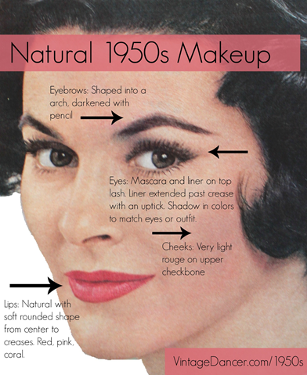

Mrs. Peterson (here with Rosie and Albert): lower bun, fascinator, red lips, blush, wrinkles
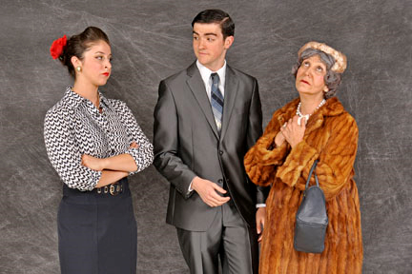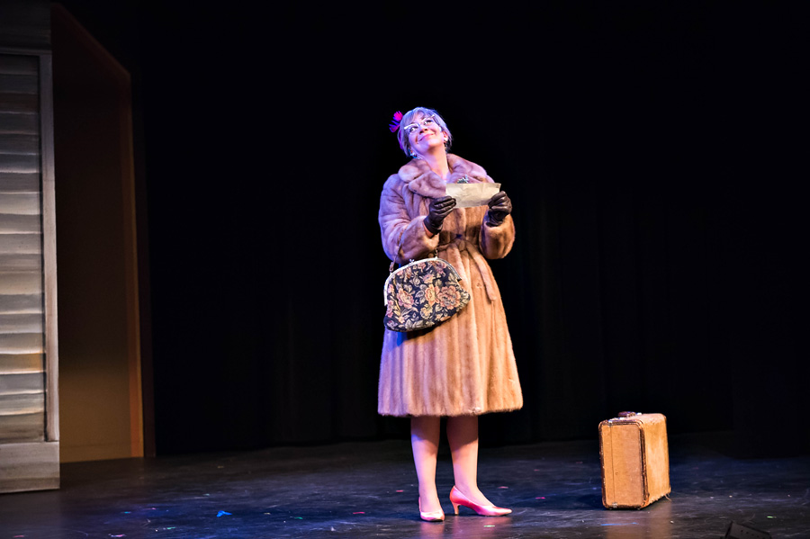

Rosie: arched brows, eye liner, mascara, bright red lips, low bun
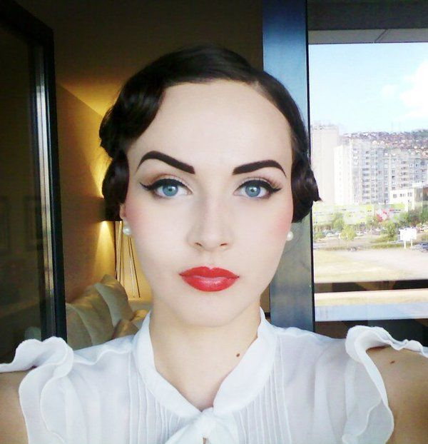

Kim: Half ponytail, natural makeup …
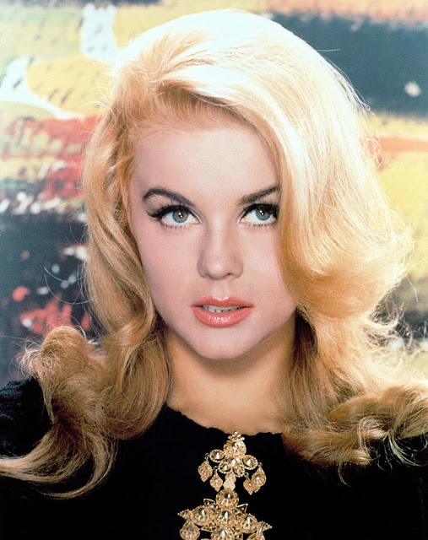

Happy Face & Happy Apple Teens: arched brows, eye liner, mascara, natural, pink or coral lips, high pony tail or side tail with a colorful scarf in it
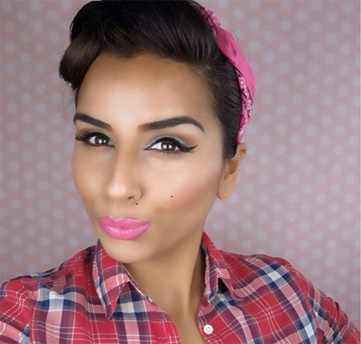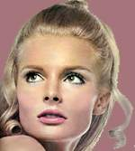

Conrad: spiky cool dude hair
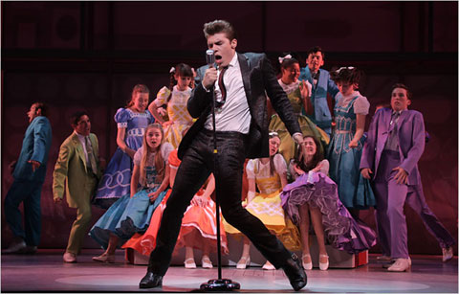

Mr. & Mrs. MacAfee: Low bun, red lips, blush, eyeliner, mascara, neat, gelled & parted hair for dad
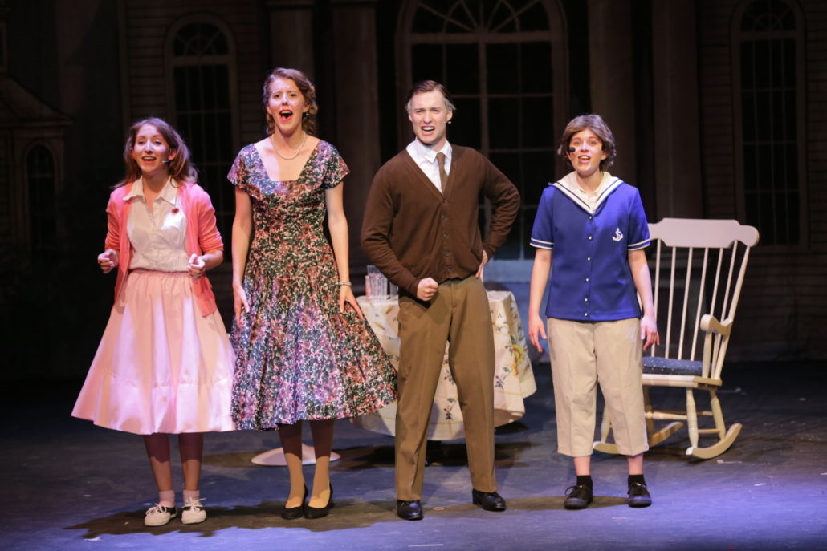

Men: Women:
